ASTRO PLAYSAFE PREMIUM TPV

(TPV – THERMO PLASTIC VULCANISED RUBBER)

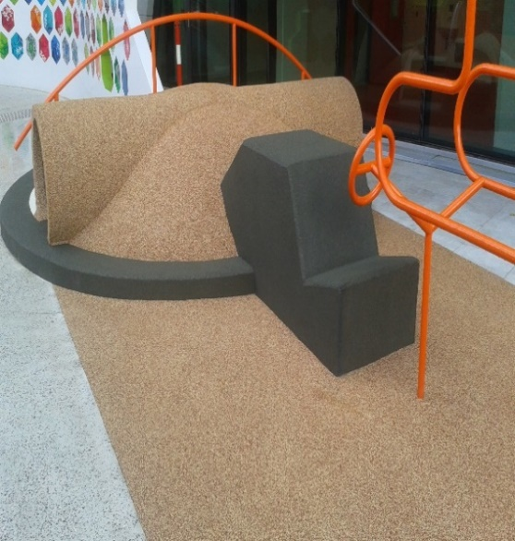
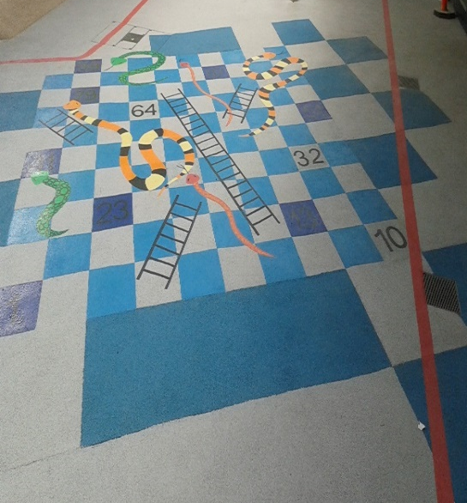
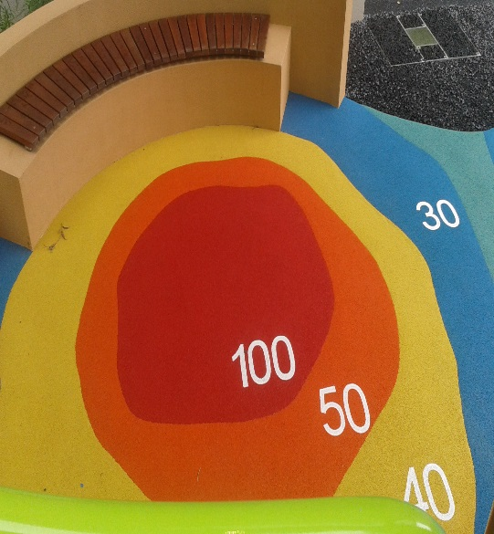

New Children’s Hospital Perth WA

- Manufactured and supplied by Rosehill Polymers, UK
- TPV was developed in collaboration between Rosehill Polymers and Dupont Dow
- Excellent colour consistency and UV stability – suitable for the Australian climate
- NINETEEN (19) COLOURS TO CHOOSE FROM OR BLENDED
- FIVE (5) YEAR PRODUCT WARRANTY PROVIDED BY SUPPLIER
- THREE (3) YEAR IMPACT TEST WARRANTY PROVIDED BY ASTRO SYNTHETIC SURFACES
- Installation complies with AS/NZS 4422:2016
- WITH REGULAR MAINTENANCE, THE ANTICIPATED SURFACE LIFE EXPECTANCY IS TEN (10) YEARS PLUS

